CS 255 System Design Document Template

UML Use Case Diagram

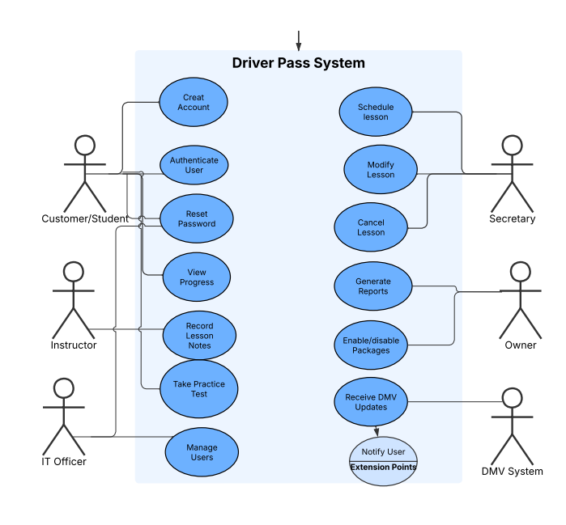

UML Activity Diagrams
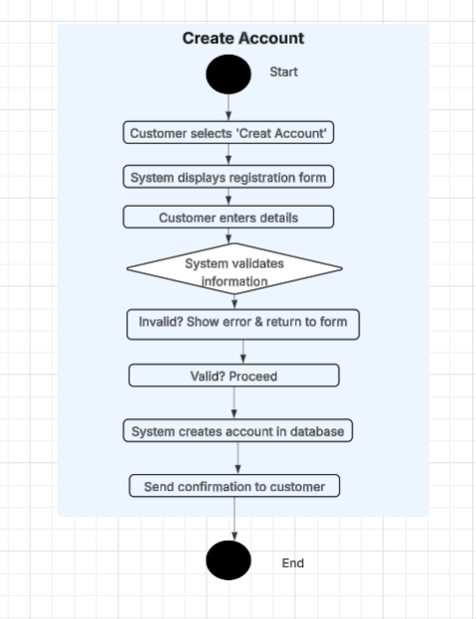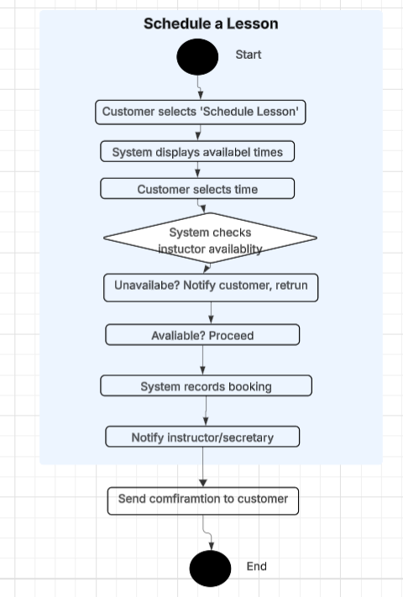

UML Sequence Diagram
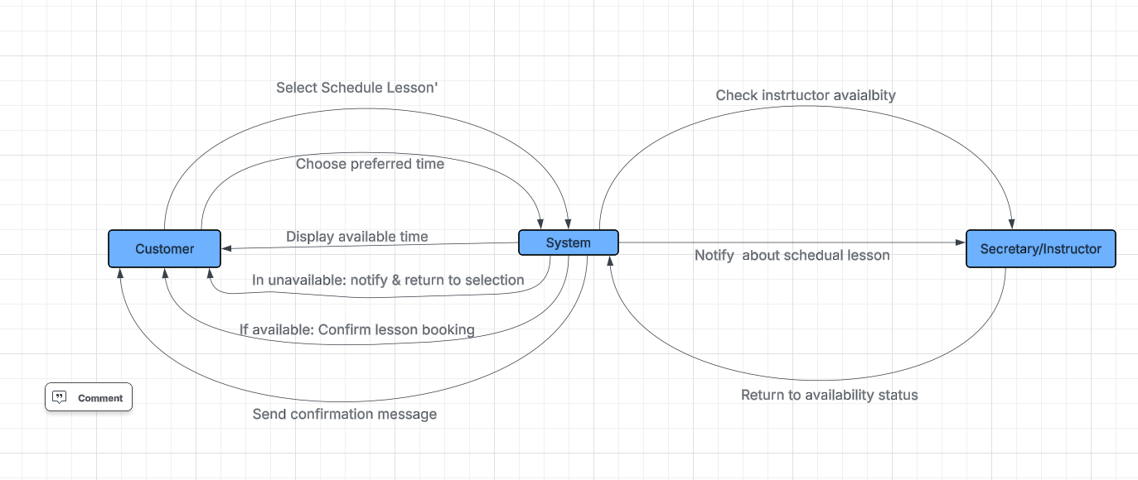

UML Class Diagram
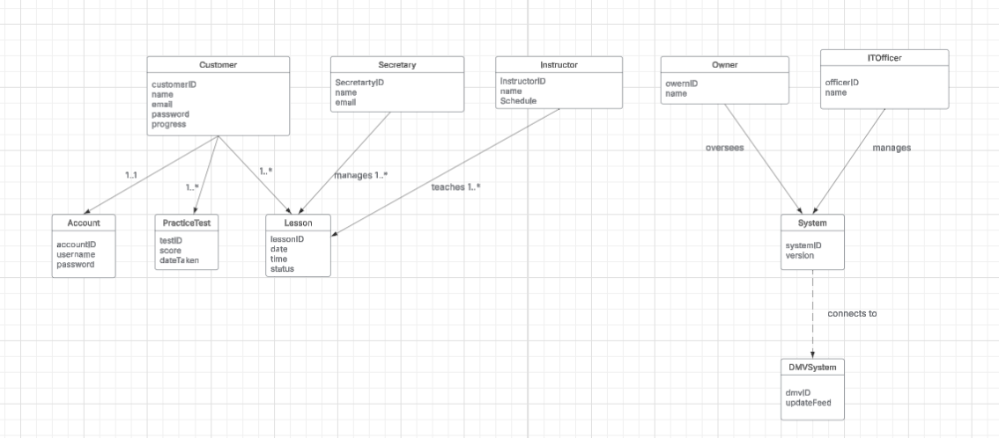

Technical Requirements
The technical requirements for the DriverPass system are designed to support the functional and nonfunctional needs outlined in the business requirements. The system will be cloud-hosted on platforms such as AWS or Azure to ensure scalability, security, and high availability. The infrastructure will include secure servers with sufficient processing power, memory, and storage, along with load balancing to support concurrent users. A relational database such as MySQL or PostgreSQL will be used to manage user accounts, reservations, training packages, and progress tracking. The system will operate as a web-based platform, accessible on common browsers and mobile devices, ensuring compatibility across Windows, macOS, iOS, and Android environments. The design will feature a responsive interface so that customers, secretaries, instructors, and administrators can easily interact with the system.
Security is a core requirement. All communication between clients and the server will use HTTPS with TLS encryption, and sensitive data, including payment information, will be encrypted both in storage and in transit. Additional protections such as password hashing, secure reset processes, and temporary account lockouts will prevent unauthorized access. The IT officer and owner will be provided with role-based tools to manage accounts, oversee packages, and generate reports. Reporting dashboards with export functions and a notification system for reminders and DMV updates will support business operations. To ensure reliability, the system will include daily automated backups, disaster recovery planning, and API integration with DMV systems for policy and content updates. These requirements collectively establish a secure, accessible, and adaptable system capable of supporting DriverPass’s mission to improve student driving test success.

Source
Rath, A., Spasic, B., Boucart, N., & Thiran, P. (2019). Security pattern for cloud SaaS: From system and data security to privacy case study in AWS and Azure. Computers, 8(2), 34. https://doi.org/10.3390/computers8020034

